MINI PROJECT REPORT

AI CUSTOMER SUPPORt CHATBOT

Submitted by:KAMALI M

Department: B.TECH AI&DS

College Name: DHANALAKSHMI SRINIVASAN UNIVARSITY

Academic Year: 2024-2028

Technologies Used: Python, Flask, HTML, CSS and JavaScript

ABSTRACT :
The AI Customer Support Chatbot is a web-based application designed to answer common customer questions for an online shopping business.
Customers can type questions in natural language and receive responses about business working hours, product prices, delivery, return policies and general support.
The application uses Python and the Flask framework to process incoming messages and return suitable responses. HTML provides the page structure, CSS styles the interface, and JavaScript supports interaction between the user and the chatbot. When the application does not contain the requested information, it provides a fallback response instead of presenting an unsupported answer.
The project demonstrates how a simple chatbot can make basic customer information easier to access. The current prototype uses predefined business information and rule-based matching;

INTRODUCTION:
Customer support is an important part of online shopping. Customers often need quick information about products, prices, working hours, delivery and returns. If every question must be answered manually, customers may have to wait and support staff may spend time repeating the same information.
A customer support chatbot provides a simple way for users to ask questions through a web interface. This mini project, named Smart Store Assistant, demonstrates a chatbot for an imaginary online store. Users enter a question in the chat window and receive a response based on the information configured in the application.The project combines a Python backend with a browser-based interface. Flask handles web requests, while HTML, CSS and JavaScript provide the user interface
It is not a fully trained machine-learning model.

OBJECTIVES AND EXISTING SYSTEM:

Specific objectives:

• Create a clean web-based chat interface.

• Allow customers to enter questions in natural language.

• Provide information about working hours, product prices, delivery and return policies.

• Match common question patterns with relevant predefined responses.

• Display a suitable fallback message when information is unavailable.

• Test the application with a range of inputs.

• Capture screenshots and prepare project documentation.
However, this prototype does not connect to real orders, payment systems or live customer-service agents. document the interface and observed results
PROPOSED SYSTEM AND TECHNOLOGIES:
The proposed system is a browser-based chatbot for the Smart Store demo business. A customer types a message and submits it using the Send button. JavaScript sends the message to the Flask backend. The backend checks the message against configured patterns or keywords and selects an appropriate response. The response is then displayed in the chat window. Technologies used:

• Python: implements the backend logic and response selection.

• Flask: creates the web application and handles requests.

• HTML: defines the chatbot interface structure. • CSS: controls layout, spacing, colours and visual appearance. • JavaScript: handles message submission and updates the conversation display.

• Web browser: provides the interface used to test the application. The project can be developed and tested locally on a Windows laptop. The displayed store details and product price are sample data for the prototype and should be updated if different information is required.

SYSTEM ARCHITECTURE AND DESIGN:
The system follows a simple client-server architecture. System flow:
1. 1. The customer opens the chatbot page in a browser.

2. 2. The customer enters a question in the message field. 3. 3. JavaScript submits the message to the Flask application.
4. 4. Flask passes the message to the response-handling logic.
5. 5. The logic checks available business information and selects a response.
6. 6. Flask returns the response to the browser.
7. 7. JavaScript displays the response in the conversation. Main modules:
• User Interface Module: displays the chat window, messages and input field.
• Request Handling Module: receives the user message from the browser.
• Response Matching Module: identifies known question types and chooses configured replies.
• Fallback Module: The application depends on the Flask server being active while accessed locally. In this version, responses are based on predefined information rather than a live database or external AI service.

IMPLEMENTATION :
The project is organised into a small set of files. The app.py file contains the Flask application and backend response logic. The templates/index.html file defines the page structure. The static/style.css file controls the interface appearance, and static/script.js manages user interactions. Implementation procedure.
1. Install Python and confirm that it is available from Command Prompt.
2. Install Flask in the Python environment.
3. Create the project folders and required files.
4. Add the Flask route and response logic to app.py.
5. Build the chat interface in index.html.
6. Style the interface using style.css.
7. Add JavaScript to submit messages and display replies.
8. Run the application using the command python app.py from the project directory.
9. Open the local address printed by Flask in a web browser.
10. Test common questions and record the results. The prototype demonstrates expected responses for greeting, working-hours and product-price questions. Delivery, return-policy and unknown-question responses should be tested and documented according to the actual output on the user's laptop.
SCREENSHOTS:

Screenshots provide visual evidence that the application interface was created and tested. Insert genuine screenshots captured from the running project in this section.

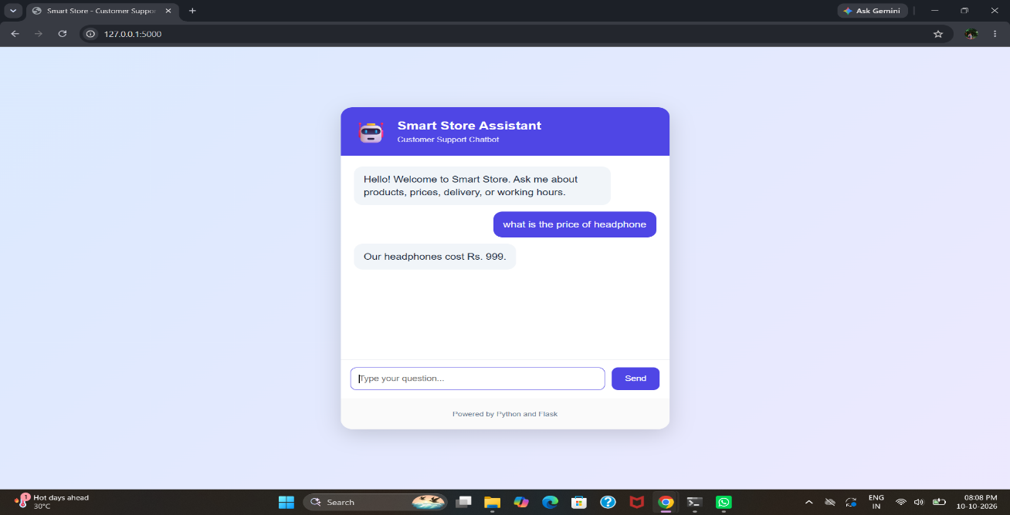

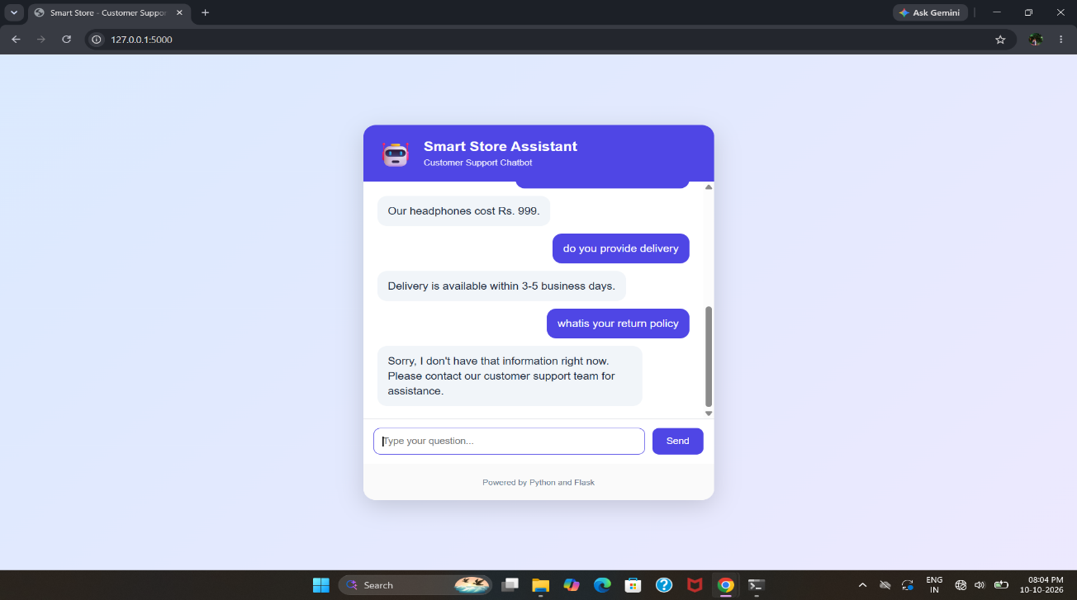
TESTING AND RESULTS:
Testing checks whether the chatbot responds appropriately to different inputs. The following table is a template; update each result based on tests actually completed.
Test 1 — Greeting Input: “hello”
Expected result: A welcoming greeting.
Status: Pass (based on the recorded screenshot).
Test 2 — Working hours Input: “what are your working hours” Expected result: Store working hours are displayed. Observed result: Monday to Saturday, 9 AM to 6 PM.
Status: Pass (based on the recorded screenshot).
Test 3 — Product price Input: “what is the price of headphone
Observed result: The chatbot displayed Rs. 999.
Status: Pass (based on the recorded screenshot)
Test 6 — Unknown question Input: “Tell me about your space travel service”
\Expected result: A polite fallback message indicating that the information is unavailable. Observed result: [Record the actual response.]
Status: [Pass/Fail after testing.] The tests show how the application handles supported question patterns. The final report should contain accurate observed results and screenshots for the completed tests.

CONCLUSION AND FUTURE ENHANCEMENTS:
The AI Customer Support Chatbot mini project demonstrates a simple web application that responds to common customer questions.
Python and Flask provide the backend, while HTML, CSS and JavaScript create the interactive browser interface. The prototype can provide configured information such as working hours and product prices and can be extended to cover delivery, returns and other frequently asked questions. The project helped demonstrate web application development, request handling, response matching, interface design and functional testing. Its current limitation is that it relies on predefined information and pattern matching.
It does not automatically understand every possible question, access live order information or provide verified real-time business data. Future enhancements may include connecting a product database, adding order tracking, supporting more languages, improving natural-language understanding, adding a secure administrator interface, and deploying the application to a web hosting platform.
These features would make the chatbot more useful for a real online store. In conclusion, the project provides a practical foundation for learning how customer-support chatbots are designed, implemented, tested and documented.

